**Lecture87,88,89,90: Implementing API GATEWAY**

**Why is API Gateway needed :**

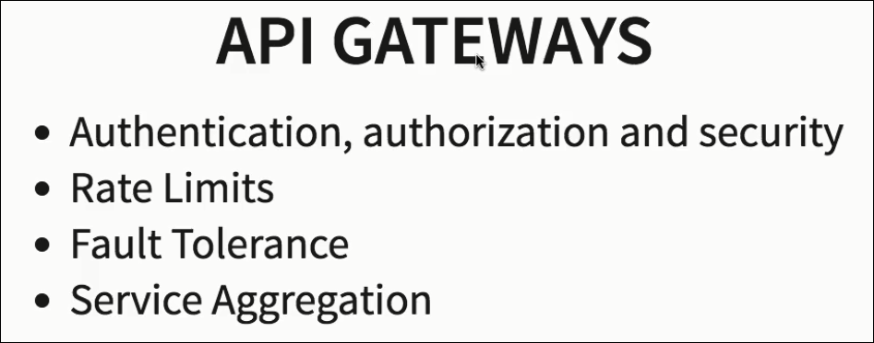**\*\* API Gateway is the best place to perform a : Analytics, Debugg, Call tracing etc.**

**Action1:Setup Zuul API Gateway.**

**Step1: Initialize & download**

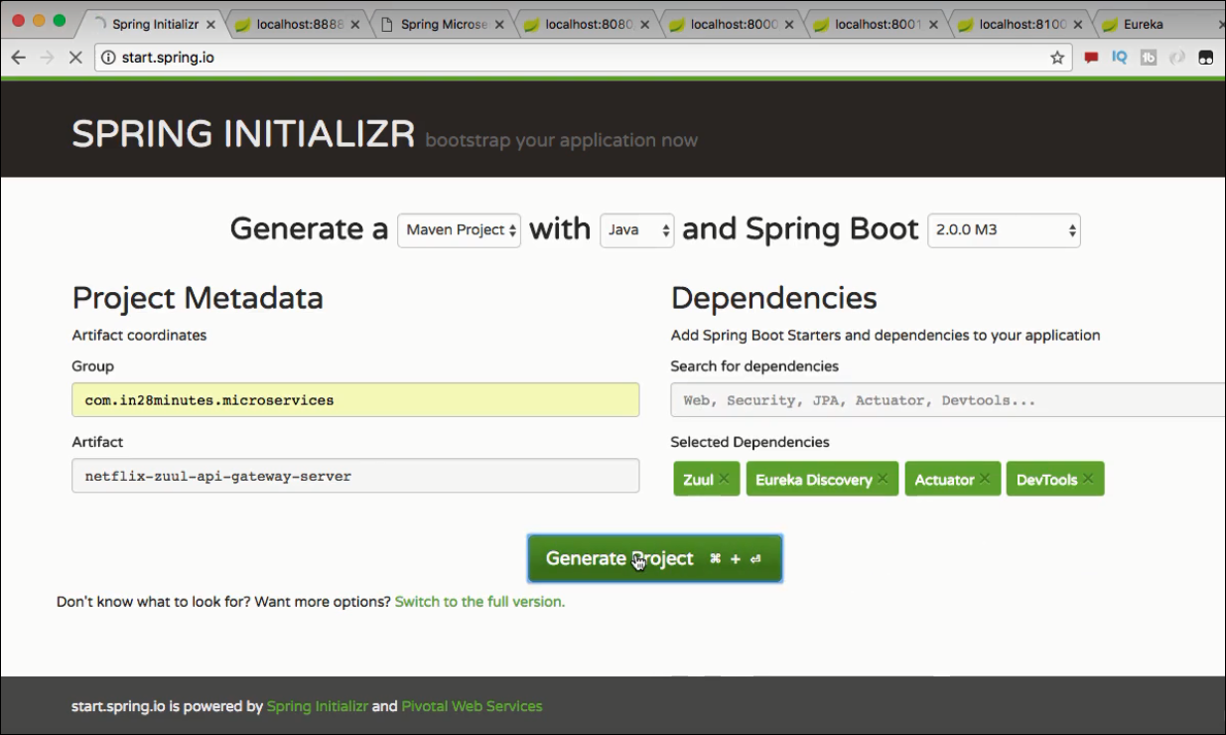

**Step2: Import to workspace as “Existing Maven Project”**

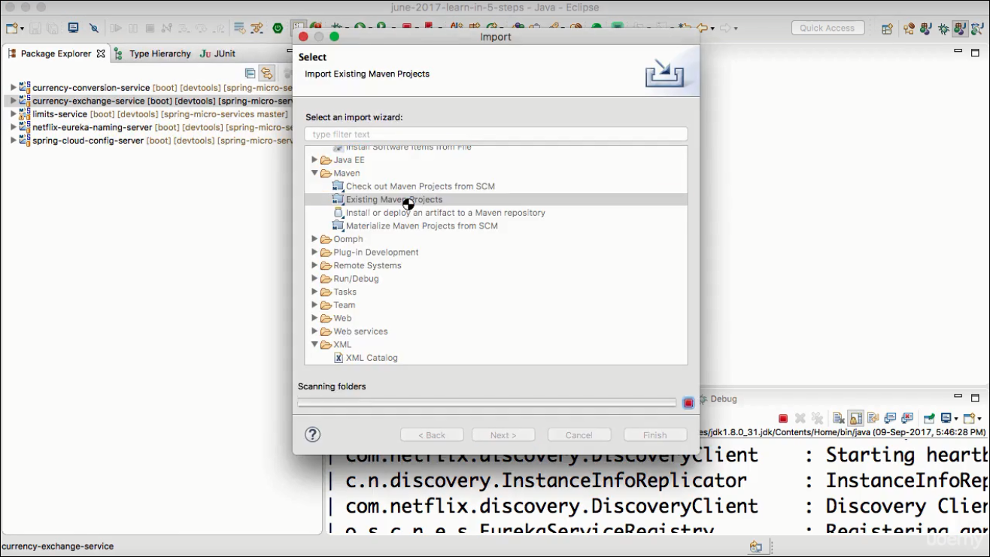

**Step3: Configure the API Gateway Project**

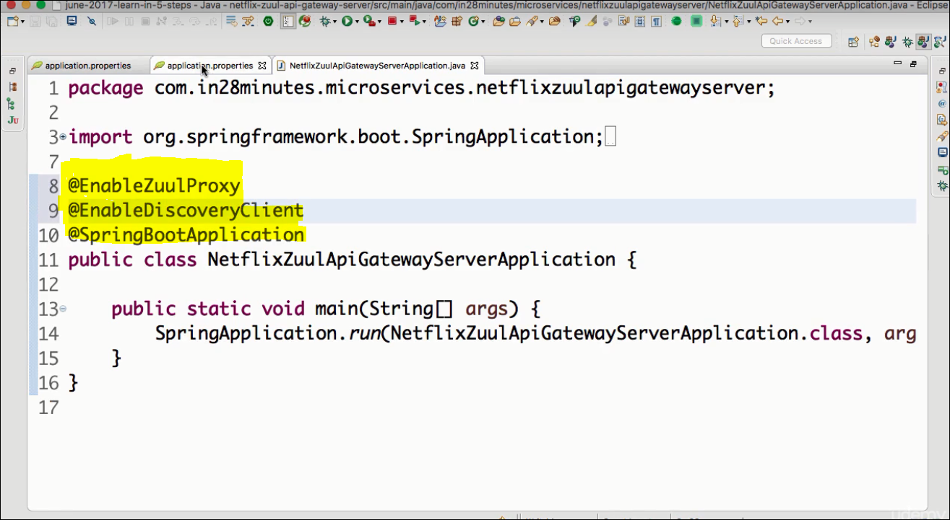

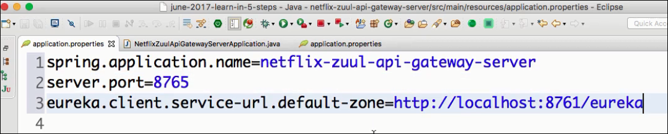**Lecture 89:**

**Action 2: Define what to do when API Gateway intercept the request**

**Ex: Logging**

**Step1: Add the Filter implementation for the Zuul.**

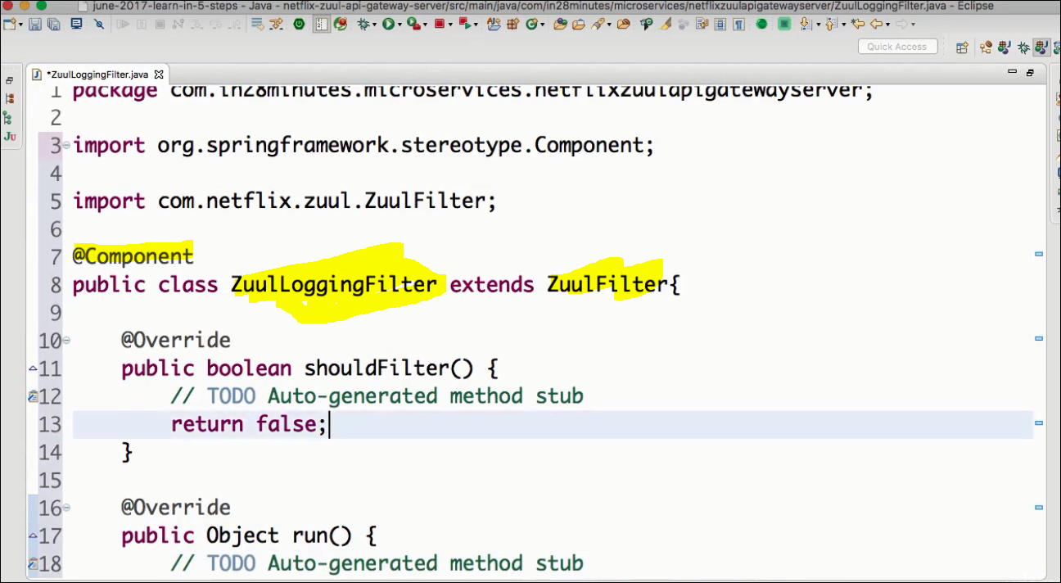

boolean **shouldFilter() →** used to evaluate if the filter should be applied or not on this request.

[return true]

Object **run() →** task to be performed.

String **filterType() →pre,post,error,all.**[ *return “pre”*]

int **filterOrder() →** set the priority order , when multiple filters are present.[ *return 1*]

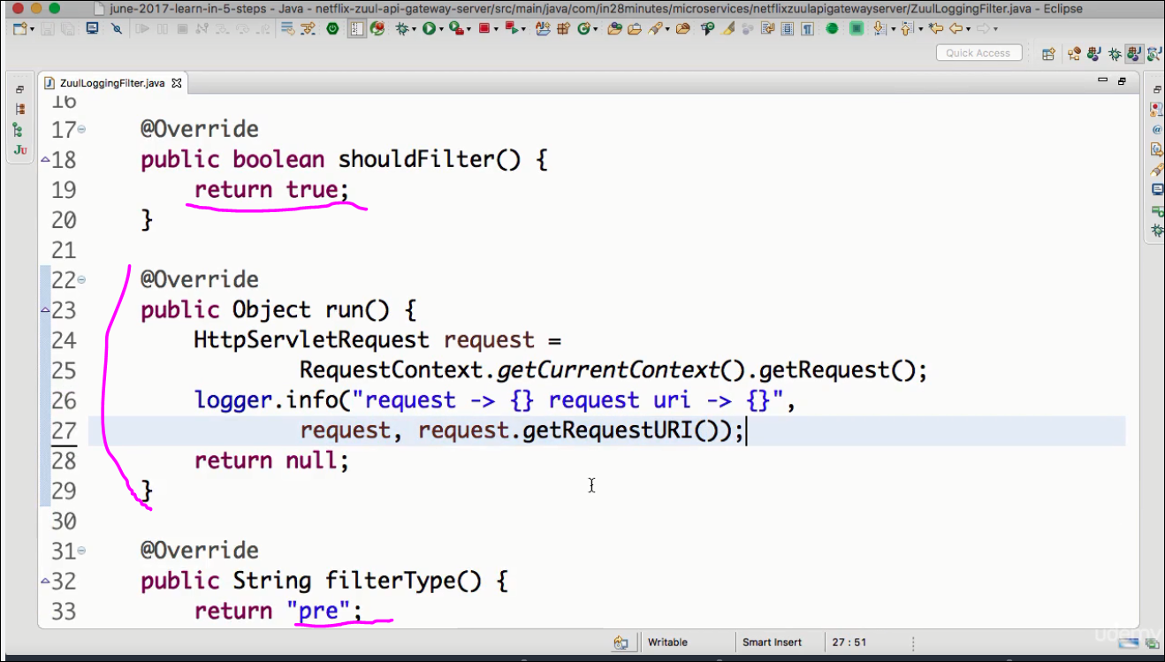

**Action 3: Invoking Zull API Gateway**

**Step1:Make sure the following services are up n running in the order:**

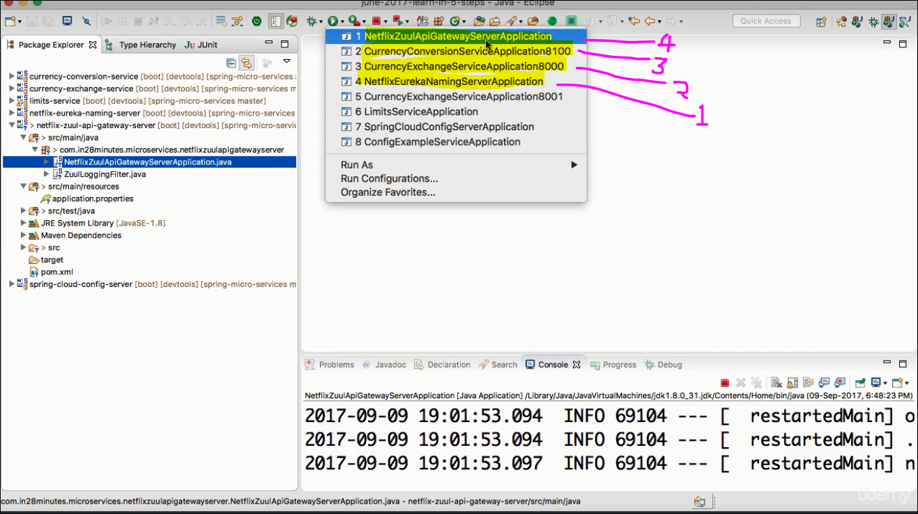

**Step2: Ensure all the services are**

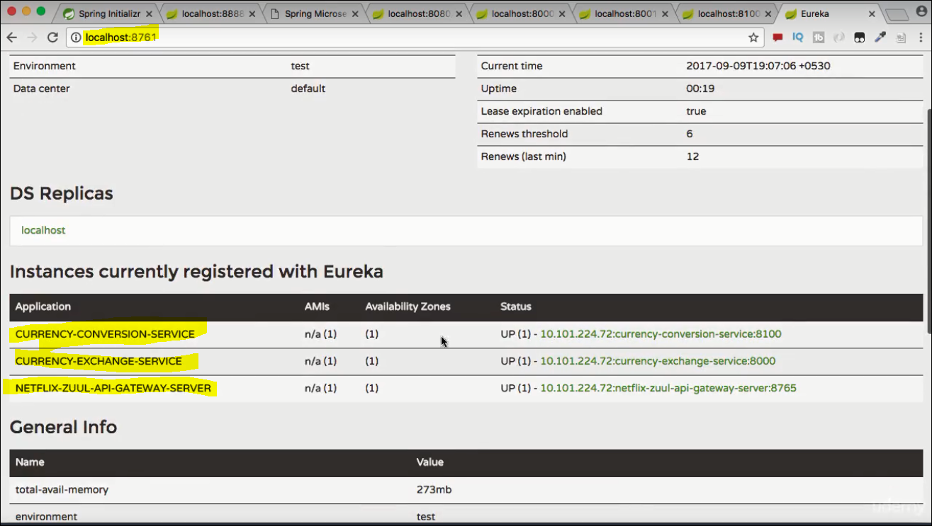

**Step3: Invoke the Currency Exchange Service**

**If we invoke it directly it will not go through API Gateway**

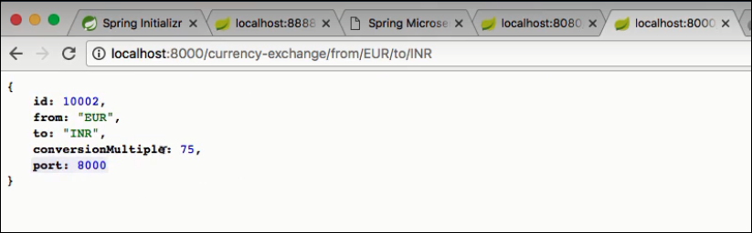

**lets convert the URL :**

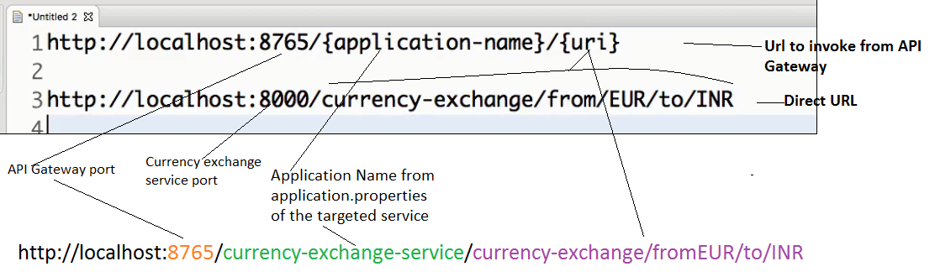

**test it on browser:**

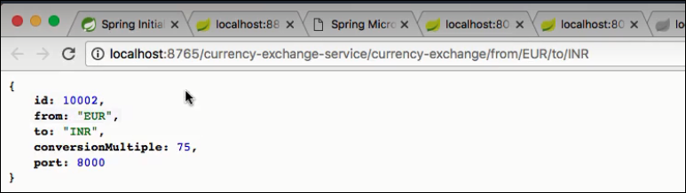

**Check the logs to see the output:**



**Action 4: Lets update Feign client of CCS m/s to call the CES service via gateway rather than its direct URL. Update the fein client proxy as below.**

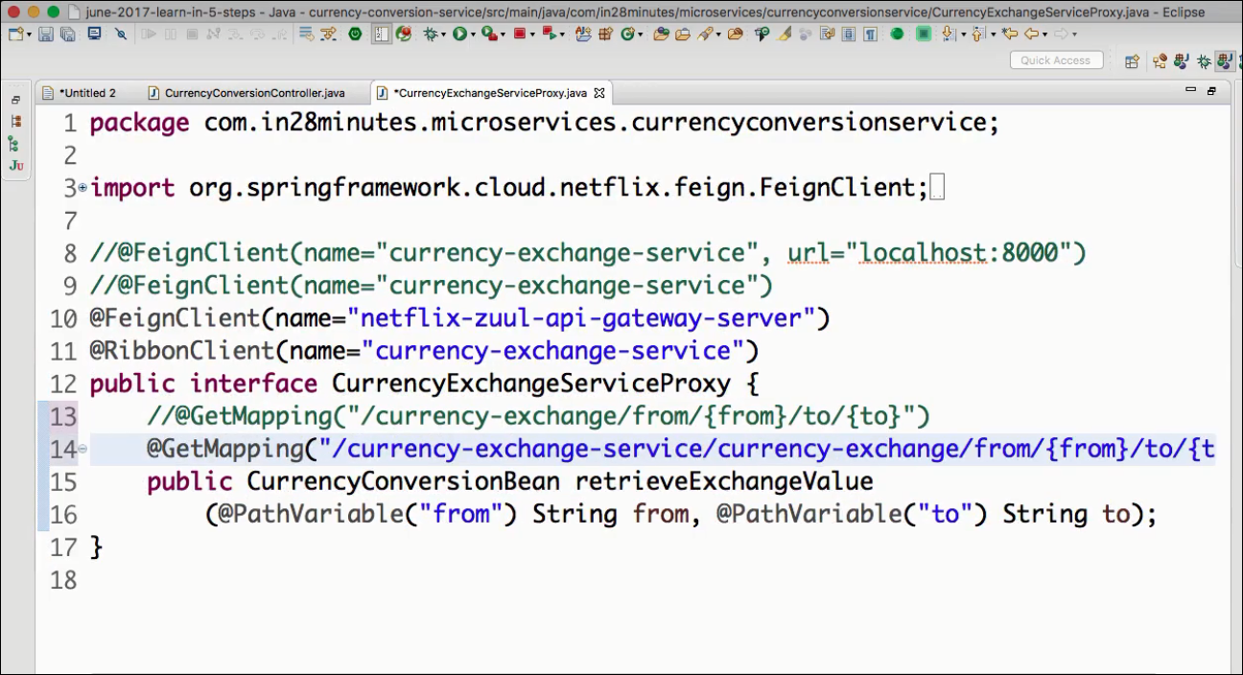

**Now we can call the CCS from its URL( the one that used feign client) & see it calls the CES via API gateway from its feign client.**

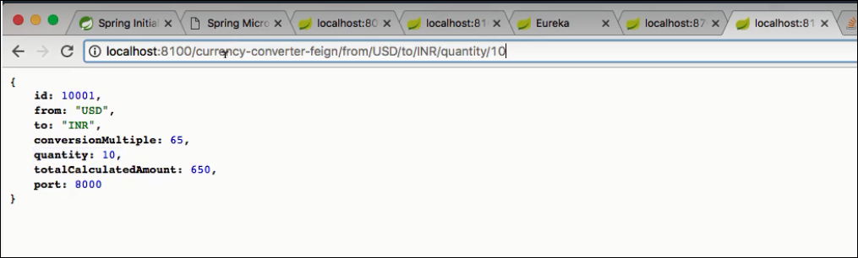

**CCS → API GATEWAY → CES**

**lets make it pass through API GATEWAY even before coming to CCS.**

**API GATEWAY → CCS → API GATEWAY → CES**

